**Solver Problems**

**Investment Decision**

Brian Givens is a financial analyst at Retirement Planning Services who specializes in designing retirement portfolios for retirees using corporate bonds. He has just completed a consultation with a client who expects to have $750,000 to invest when she retires next month. Brian and his client agreed to consider upcoming bond issues from the following six companies.

|  |  |  |  |
| --- | --- | --- | --- |
| **Company** | **Return** | **Years to Maturity** | **Rating** |
| Acme Chemical | 8.65% | 11 | 1-Excellent |
| DynaStar | 9.50% | 10 | 3-Good |
| Eagle Vision | 10.00% | 6 | 4-Fair |
| MicroModeling | 8.75% | 10 | 1-Excellent |
| OptiPro | 9.25% | 7 | 3-Good |
| Sabre Systems | 9.00 | 13 | 2-Very Good |

The column labled **Return** in the table represents the expected annual yield on each bond, the column **Years to Maturity** indicates the lenghth of time over which bonds are payable,and the column **Rating** indicates an independent underwriter’s assessment of the quality or risk associated with the bond.

Brian believes that all companies are relatively safe investments. However, to protect his client’s income, Brian and his client agreed that no more than 25% of her money should be invested in any one investment and at least half of her money should be invested in long-term bonds that mature in 10 or more years. Also, even though DynaStar, Eagle Vision, nd OptiPro offer the highest returns, it was agreed that no more than 35% of the money should be invested in these bonds because they represent the highest risk (they are lower than Very Good).

Brian needs to determine how to allocate his client’s investemnts to maxi,ize her income while meeting their agrred upon restrictions.

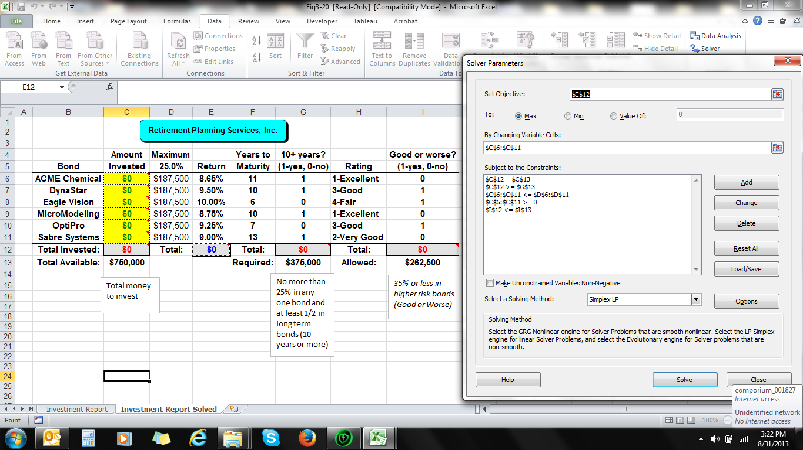

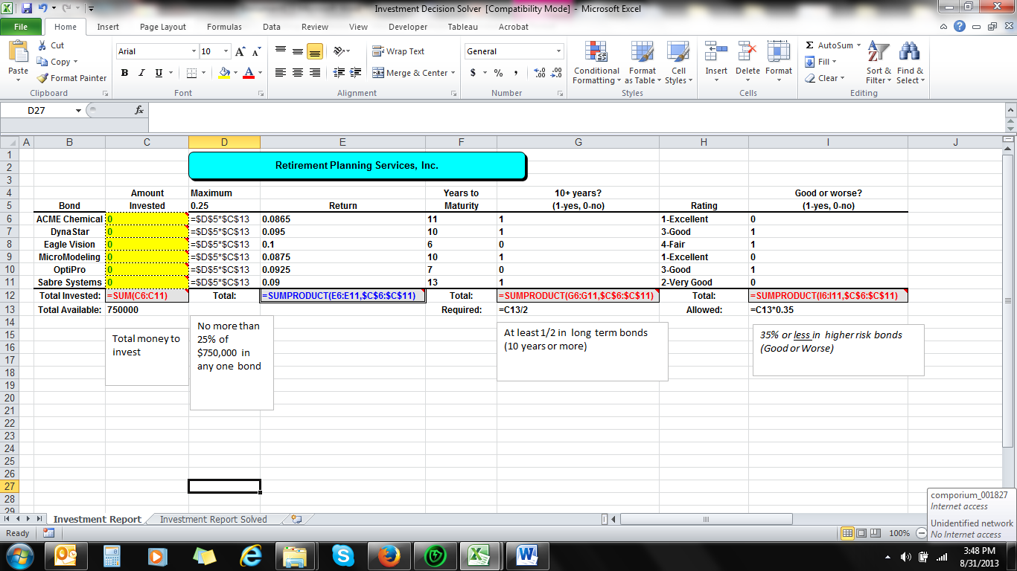

**Transportation Problem**

Tropicsun is a leading grower and distribeuter f fresh citrus products with three large citrus groves scattered around central Florida in the cities of Mt Dora, Eustis, and Clermont. Tropicsun currently has 275,000 bushels of citrus at the grove in Mt. Dors, 400,000 bushels at the grove in Eustis, and 300,000 bushels at the grove in Clermont, Tropicsum has ciitrus processing plants in Ocala, Orlando, and Leesburg with processing capabilities to handle 200,000, 600,000 and 225,000 bushls repectively. Tropicsun contracts with a local trucking company to transport its fruit from the groves to the processing plants. The trucking company charges a flat rate for every mile that each bushel of fruit must be transported. Each mile a bushel of fruit travels is known as bushel-mile. The following table summarizes the distances (in miles) between the groves and the processing plants

|  |  |  |  |
| --- | --- | --- | --- |
|  | **Distances (in miles) Between Groves and Plants** | | |
| **Grove** | Ocala | Orlando | Leesburg |
| Mt. Dora | 21 | 50 | 40 |
| Eustis | 35 | 30 | 22 |
| Clermont | 55 | 20 | 25 |

Tropicsun wants to detrmine how many bushels to ship from each grove to each processing plant in order to minimize the total number of bushels-miles the fruit must be shipped.

|  |  |  |  |  |
| --- | --- | --- | --- | --- |
| **Supply** | **Groves** | **Distances** | **Processing Plants** | **Capacity** |
| 275,000 | 35  40  21  Mt.  Dora  1 | 50 | Ocala  4 | 200,00 |
|  | Eustis  2 |  | Orlando  5 |  |
| 400,000 |  | 30 |  | 600,000 |
|  | 22 |  |  |  |
|  | 55 |  |  |  |
|  | Clermont  3 |  | Leesburg 6 |  |
|  | 20 |  |  |  |
| 300,000 |  | 25 |  | 225,000 |

**Heuristic Solution to Model**

1. 20 miles: Clermont (300,000) to Orlando. Deplete supply at Clermont
2. 21 miles: Mt. Dora (200,000) to Ocala. Depletes capacity at Ocala
3. 22 miles: Eustis (225,000) to Leesburg. Depletes capacity at Leesburg
4. 30 miles: Eustis (175,000) to Orlando. Depletes remaining supply at Eustis
5. Only remaining route is Mt. Dora to Orlando because capacities at Ocala and Leesburg have been depleted. The max. we can ship is the smaller of remaining supply at Mt. Dora (75,000) and remaining capacity at Orlando (125,000). So we ship the final 75,000 at Mt. Dora to Orlando. This depletes supply at Mt. Dora
6. Solution ships the fruit a total of 24,150,000 bushel-miles. All bushels available at each grove have been shipped and none of capacities at the plants have been exceeded.

This is a **feasible** solution. Is it **optimal**?

­­­

